Engineering Leadership Certificate

Student Handbook

Last Revised 8/22/2016

Foreword: Learning to Lead

By David Niño
Professor in the Practice of Engineering Leadership, Brown School of Engineering
Lecturer in Management, Jones Graduate School of Business
Faculty Associate, Leadership Rice

One of the goals surrounding Rice’s centennial celebrations is to “Transform Extraordinary Students into Extraordinary Leaders.” While this may seem like a bold aspiration, it is not a new one. Rice was founded on the ideal of becoming a leading university that develops leaders across the spectrum of the human endeavor. These ideals are embodied in our mission and Rice has indeed become a leading university.

Our university has also succeeded in producing leaders across many areas, including science, technology, education, business, and the arts. Rice graduates are also making an impact in areas of public policy. In fact, on the year of Rice’s centennial, Houston and Harris County’s top two elected positions are both held by Rice alumni! But while holding top positions is one way of leading, there are many other meaningful ways of exercising leadership.

The goal of the Certificate in Engineering Leadership is to integrate a set of ideas to help members of the Rice community learn, teach, and practice in the area of leadership. Many in our community already have at least a common sense understanding of what leadership means. As recent research shows, however, efforts to develop leadership are facilitated when teachers and learners are guided by an integrated framework and model. These frameworks not only provide a clear focus for skill development and assessment, they also provide a common language for talking about leadership.

Through RCEL’s Certificate in Engineering Leadership, students will gain an intimate knowledge of leadership theory, practice, and insight, while developing their own vision for what leadership means to them. The overarching framework for this development program stems from several key development areas: Envisioning, Engaging, Executing and Embedding, all built upon a base of continuously improving self-knowledge. These “Four E’s” bring together the entire leadership process that defines personal, team, and community interactions. Over the long term, these attributes transform students, instructors, and communities into the “Extraordinary Leaders” Rice strives to produce.

Table of Contents

- Foreword

- Vision & Mission

- RCEL History

- RCEL Contact Information

- Certificate Overview

- Certificate Requirements
- Certificate Timeline
- Certificate Application Process

- The RCEL Experience
  - Academic Year Overview
  - Timeline
  - RCEL Leadership Competencies
  - Professional Internship Experience
  - Leadership Experience Component
  - Leadership Portfolio
  - Leadership Experience Presentation

Vision and Mission
Mission Statement: To educate and develop Rice engineers to become inspiring leaders, exceptional team members, effective communicators, and bold entrepreneurs.
Program Goals:
- To encourage all Rice engineering students to lead engineering innovation, invention, and implementation efforts globally.
- To lead the nation in Engineering Leadership education by designing and sharing a curriculum that develops effective engineering leaders.
- To train RCEL students to perform according to the Code of Ethics established by the National Society of Professional Engineers - http://www.nspe.org/resources/ethics/code-ethics
- To prepare RCEL students to assume leadership role in the following areas within 3-5 years of graduation:
- engineering projects or teams
- management
- technical implementation (see below)
- To prepare RCEL students to assume leadership in the following roles within 20 years of graduation:
- executive leadership
- policy
- entrepreneurship
- research
- academia

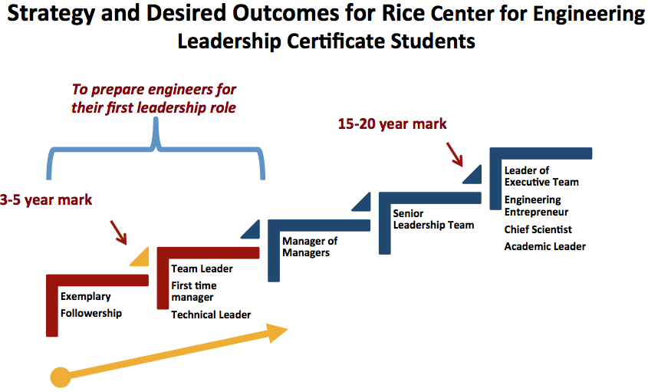
RCEL History

In 2009, Rice graduates Ann and John Doerr endowed the Rice Center for Engineering Leadership (RCEL) with a $15 million gift from the Beneficus Foundation with the goal of preparing the next generation of Rice engineers to become technical and entrepreneurial leaders.

RCEL was formally launched on November 5, 2010, and has evolved with input from faculty, graduate students, undergraduate students, and external advisors, including industry consultants and representatives from engineering leadership programs at peer academic institutions.

The foundational programming of RCEL was designed to provide undergraduates with enhanced engineering design opportunities and connect students with professional mentors and engineering leaders.

As RCEL expanded, the vision for a more structured educational experience began to take shape, and the framework for the Certificate in Engineering Leadership emerged. Through rigorous coursework, professional experiences, and extracurricular leadership opportunities, the Certificate Program offers a comprehensive introduction to engineering leadership.

The Certificate Program culminates in the creation of a comprehensive individualized leadership portfolio, which documents the personal, academic, and professional leadership growth of the student over the course of his or her time in the program. In order to receive the Engineering Leadership Certificate, each student must deliver a final “Leadership Experience Presentation” that summarizes the information included in the leadership portfolio. Ultimately, the goal of the Certificate is to equip engineering leaders with the important technical, communication, and leadership skills necessary to, as John Doerr puts it, “Rock the world!”

RCEL Contact Information

RCEL Online

Official Website | http://rcel.rice.edu
- To apply for admission to the Engineering Leadership Certificate Program:
Certificate Application | http://rcel.rice.edu/apply

- To apply for RCEL sponsorship of a project, team, event, etc.:
Sponsorship Application | http://rcel.rice.edu/sponsorship

- To access forms (including assessments) for ENGI 218/219 & 318/319:
Leadership Lab Forms | http://rcel.rice.edu/labs

http://www.facebook.com/RCELRICE

http://www.twitter.com/RCELatRiceU

RCEL Faculty & Staff

C. Fred Higgs III, Ph.D. | Faculty Director
higgs@rice.edu | 713-348-4993 | 228 Mechanical Engineering Bldg.

Kaz Karwowski | Executive Director
karwowski@rice.edu | 713-348-2359 | Abercrombie A101

David Van Kleeck, Ph.D. | Professor in the Practice of Engineering Leadership
david.vankleeck@rice.edu | 713-348-3514 | Mech Lab 104

Tom Phalan | Lecturer in Engineering Leadership
tom.phalan@rice.edu | 713-348-3514 | Mech Lab 104

Chuck Roberts | Lecturer in Engineering Leadership
cmroberts1955@gmail.com.edu | 713-348-3514 | Mech Lab 104

Germaine Porche | Lecturer in Engineering Leadership
germaine.porche@rice.edu | 713-348-3181 | Abercrombie Lab A102

Jan Hewitt, Ph.D. | Senior Lecturer in Communications
jhewitt@rice.edu | 713-348-6224 | Abercrombie A109

Beata Krupa, Ph.D. | Lecturer in Professional Communications
bkrupa@rice.edu | 713-348-2731 | Abercrombie A106

Gayle Moran, Ph.D. | Lecturer in Professional Communications
gayle.moran@rice.edu | 713-348-5731 | Mech Lab 106

Beth O’Sullivan | Lecturer in Professional Communications
betho@rice.edu | 713-348-3851 | McNair Hall 263

Tina Peterson, Ph.D. | Lecturer in Professional Communications
clp7@rice.edu | 713-348-3181 | Abercrombie A102

Cesare Wright | Leadership & Outreach Specialist
cesare@rice.edu | 713-348-2623 | Abercrombie A107

Amanda Prestia | Marketing and Events Specialist
aprestia@rice.edu | 713-348-2731 | Abercrombie A106

Christine Gardner | Administrator
chrisg@rice.edu | 713-348-3181 | Abercrombie A102

Certificate Overview

RCEL programming enhances the traditional undergraduate education by developing skills that are not expressly covered in the Rice Engineering curriculum. Through a series of curricular and co-curricular learning experiences, RCEL students learn to create and communicate a vision, build a high-performing team, form and execute collaborative plans, and create innovations that endure.

The targeted learning experiences provided by the Certificate Program are organized around four interrelated competency domains—Personal, Interpersonal, Management, and Leadership. Within each of these macro-domains, students will refine a variety of associated skills and proficiencies. Using assessment data, each student creates an individualized leadership development plan to identify areas of potential growth within each of the primary domains, with particular attention paid to the specific competencies in which they need improvement.

The Engineering Leadership Certificate Program curriculum is designed to:
Increase Ability – Develop leadership skills, capabilities, and competencies.
Enhance Motivation – Promote enthusiasm and drive to excel as a leader and engineer.
Provide Opportunity – Facilitate engineering leadership and personal growth experiences.

Certificate Requirements

Required Courses:
In order to earn an RCEL Leadership Certificate, you must successfully complete the following courses (10 credits):

ENGI 140: Engineering Leadership Development (2 credits)
ENGI 218/219: Leadership Lab I & II (2 credits total)
ENGI 315: Leading Teams and Innovation (3 credits)
ENGI 241: Professional Excellence for Engineers (1 credit)
ENGI 317: Leadership Action Learning (2 credit)
ENGI 318/319: Leadership Lab 1 & 2 (2 credit total)

ENGI 140: Engineering Leadership Development – a two credit hour course that introduces students to engineering leadership and to RCEL’s competency domains. Students in ENGI 140 engage in a semester-long autobiographical analysis of their personal strengths, motivations, and aspirations as leaders and followers. This analysis is then used to create a first draft of their leadership portfolios and their leadership development.

ENGI 218/219: Engineering Leadership Labs – a sequence of one credit hour courses that provide hands-on practice and application of leadership skills and techniques in a variety of practical situations. Through challenging and interactive engineering design-build activities, role-plays, simulations, and case studies, students begin developing their own personal styles of leadership.

ENGI 315: Leading Teams and Innovation – a three credit hour course that continues to build the interpersonal, management, and leadership skills essential to launching, developing, and leading engineering project teams. The course includes a heavy focus on communication and innovation in engineering teams.

ENGI 241: Professional Excellence for Engineers – a one credit hour applied practicum and internship course that provides guided career and professional development for engineering students in a real-world industrial, academic, research, or other professional context. Students complete the ENGI 241 internship requirement during the summer of sophomore or junior year (academic credit received during the fall semester).

ENGI 317: Leadership Action Learning – a two credit hour project based leadership practicum that allows students to apply their acquired leadership skills as a team leader on a technical engineering project.

Co-Curricular Requirements:
In addition to specified RCEL Certificate courses, Certificate students must complete the following non-course specific requirements:

Leadership Portfolio – Students must document and prepare evidence of self-directed learning and achievements (submitted prior to presentation).

Leadership Experience Presentation – Using the Leadership Portfolio and the Best Reflective Self paper as references, each student must prepare and present an exit presentation that summarizes the highlights and key takeaways that have shaped his/her view of Engineering Leadership (“Ted-Talk” style).

RCEL Lectures, Panels, & Special Events – RCEL offers a variety of ongoing leadership and professional development programming, including guest lectures, panel discussions, career/internship events, design competitions, conferences, community building events/retreats, etc. Students are encouraged to attend these events and participate in the organization and implementation of programming.

RCEL Certificate Alumnus Engagement – The RCEL leadership development experience does not end with graduation. There is a strong expectation that students will stay actively involved in the RCEL Community after they enter industry or academia. By participating as mentors, internship sponsors, guest speakers, members of the Industry Advisory Board, or in other capacities, students will continue to refine their leadership and communication skills, while further building a life-long network of personal and professional associates.
Certificate Timeline
The recommended timeline for completion of the RCEL Engineering Leadership Certificate Program is designed to provide a regimented experience in leadership development and applied practice. The Certificate consists of a series of progressive courses, activities, assignments, and projects, including the Reflective Best Self paper, Leadership Development Plan, summer internship(s), and the Leadership Project.

The following chart outlines the optimal timeline for completing the Certificate Program:
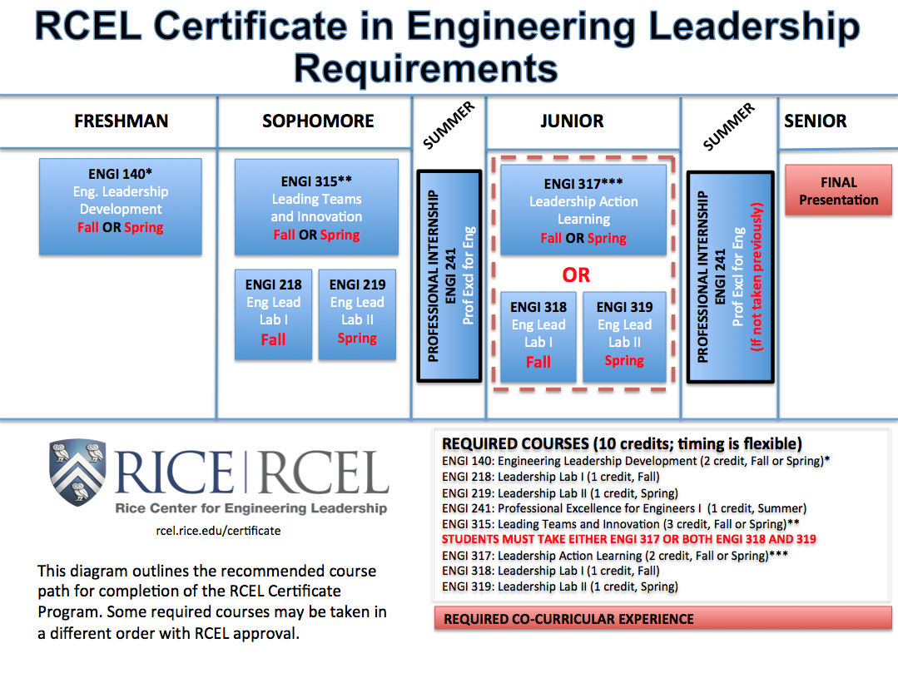Certificate Application Process

Early Deadline - Freshman year Final Deadline - Sophomore year

Students must complete and submit an online application for admission to the RCEL Certificate Program. The application is non-competitive and based on a review of the goals and academic record of the individual student. Applications will be approved by the RCEL Admissions Committee. Only Engineering majors (declared or anticipated) are eligible to earn the Certificate in Engineering Leadership. Prior to matriculation, each student must sign a written form of acknowledgement and acceptance of this policy.

Application process will be re-assessed annually by RCEL Admissions Committee.
For application instructions, please visit the RCEL website: http://rcel.rice.edu

- Upon petition, applications received after the sophomore year deadline may be considered and reviewed by the RCEL Admissions Committee on a per case basis.
The RCEL Experience

Academic Year Overview

Freshman & Sophomore Years
Through coursework and engineering leadership labs, students are exposed to the fundamentals of leadership theory and begin to develop their leadership skills.

Students have the opportunity to lead other students, participate as a member of a team, and observe the practical application of leadership practices in a team setting. Students receive feedback about their performance as a leader and develop their own unique style of engineering leadership based on that feedback and the Rice Engineering Competencies Model.

In weekly Engineering Leadership Labs (ENGI 218/219), students participate in guided team and group debriefs, emphasizing personal reflection that focuses on specific areas of improvement. To further enhance their experience in the program, students are connected with RCEL student advisors and/or mentors.

The freshman and sophomore programming and curriculum for the RCEL Leadership Certificate is designed to:

- Provide opportunities to develop and practice the individual leadership competencies.
- Develop personal self-confidence through challenging, innovative, and interactive instruction and hands-on experiential learning.
- Expose students to diverse team settings that draw from multiple engineering disciplines, cultures, and backgrounds.
- Promote responsibility and competence in delivering professional projects.
- Cultivate confidence in overall team leadership and decision making skills.
- Expose students to constructive external evaluation and assessment strategies, as well as personal reflection techniques.
- Sharpen oral, written, and multi-modal communication skills.
- Prepare students to participate as productive and effective contributors to projects and teams.

Junior & Senior Years

In the junior and senior years, students further hone the leadership skills that they developed during the first two years of the certificate.

During the junior year, students are assigned leadership positions within RCEL. For those students participating in ENGI 318/319, the Student Leadership role includes planning, leading, and evaluating the weekly Engineering Leadership Labs (ELLs) during the academic semester. Students who opt instead to complete ENGI 317 will serve in a team leadership role on a technical engineering project.

Seniors may elect to become mentors to RCEL underclassmen, organize leadership teams and events, and/or continue to contribute to the ELLs. Additionally, exemplary senior students may be invited to join the Student Advisory Board to assist in advancing RCEL programming.

Junior/senior year students continue to receive feedback on their academic, professional, and overall leadership performance. A combination of external feedback and continued personal reflection will provide the framework from which students will formulate their individualized Engineering Leadership Development Plan. The senior year will culminate in the Leadership Experience Presentation – a fifteen-minute presentation that summarizes and provides evidence to demonstrate the personal leadership growth and journey of the student during the course of the RCEL Certificate Program.

Junior and senior year Certificate programming and curriculum is designed to:

- Challenge students to become better engineering leaders by immersing them in the practical application of the RCEL Leadership Competency Model.
- Practice project engineering, organizational development, negotiation, conflict resolution, peer leadership, and other critical team-oriented skills.
- Further develop self-confidence through hands-on practice and experiential learning.
- Prepare students to lead in diverse team settings that draw from multiple engineering disciplines, cultures, and backgrounds.
- Expose students to more complex situations in which to apply constructive external evaluation and assessment strategies, as well as personal reflection techniques.
- Sharpen oral, written, and multi-modal communication skills.
- Prepare students to transition successfully from college to the engineering industry.
- Provide students with the skills and professional awareness necessary to lay the foundation for leadership advancement in the workplace within 3-5 years of graduation.

RCEL Leadership Competencies

The Engineering Leadership Certificate provides a developmental experience that enhances students’ abilities in four domains with an emphasis on specific skills associated with each domain.

Personal Domain

Competencies and Skills | Components
- Developing self-awareness – an ability to understand oneself and one’s aspirations and possibilities | - Develops an accurate and practical understanding of “who I am” and “who I can become”  - Knows personal strengths, constraints, and development opportunities  - Develops self-confidence  - Routinely seeks out and receives feedback from others  - Builds emotional intelligence  - Knows one’s basic needs, motivations, and values  - Strengthens one’s ethical values and principles
- Lifelong learning – an ability to take charge of, and manage, one’s personal growth and development | - Knows how to learn from practical experiences  - Knows one’s tolerance for ambiguity and change  - Develops professional expertise and capabilities  - Manages one’s personal and career ambitions
- Setting and achieving goals – knowing how to set personal goals, allocate resources accordingly, monitor progress, and achieve results. | - Has a personal and professional vision  - Sets SMART goals  - Takes initiative  - Plans, monitors, and manages goal achievement  - Develops drive, perseverance, and resourcefulness in achieving goals  - Achieves measureable results and learns from the process
- Managing stress – the ability to diagnose, cope with, and respond positively to stressors | - Diagnoses and identifies stressors in one’s life  - Manages reactions to stressors  - Manages time and commitments  - Builds personal resiliency and hardiness  - Develops and maintains life balance
- Problem solving and decision making – the ability to make effective decisions using rational and creative methods | - Being decisive  - Defines problems, generates alternatives, evaluates alternatives, implements solutions  - Practical ingenuity  - Learns from problem solving experiences  - Applies creative processes  - Builds intuition and insight  - Builds capacity for innovation

Interpersonal Domain

Competency | Components
- Managing conflict and negotiation – The ability to experience and manage differences in constructive ways | - Diagnoses sources and foci of conflict  - Manages emotions surrounding conflict  - Values and learns from diversity  - Understands one’s preferred conflict management style  - Matches appropriate conflict management styles to conflict situation
- Building positive relationships – The ability to initiate, create, and maintain mutually satisfying and beneficial relationships and social ties | - Understands and builds one’s emotional intelligence  - Understands mutual needs and concerns  - Creates mutually satisfying and beneficial connections with others  - Builds trust and credibility  - Assesses current networks for personal and professional purposes  - Builds and manages networks  - Builds social intelligence
- Managing followership – Being a positive, productive, and sometimes outstanding individual contributor | - Assesses current commitments and allocates time and effort to make a positive and productive impact  - Knows how to discover what is expected for strong results  - Delivers outstanding results  - Understands and manages interdependencies  - Challenges the status quo, especially when it is the “right thing to do”
- Reputation management – Builds and manages one’s personal reputation | - Develops awareness of how one is perceived by others  - Creates and manages one’s personal reputation
- Oral and written (multimodal) communication | - Inquires, listens, accurately articulates, and responds productively to the arguments of others  - Carefully communicates goals and feedback to guide collaboration and solve problems  - Communicates clearly, correctly, confidently, and persuasively in written, oral, and visual genres  - Identifies and develops multimodal communication strategies appropriate for audience and purpose  - Gathers, synthesizes, and analyzes information effectively to deploy powerful and focused arguments

Management Domain

Competency | Components
- Strategic management – Creating and implementing a shared vision, goals, objectives, and plans for achieving these aspirations | - Defining purpose, goals, and strategies  - Creates awareness of strategic context or environment (sense-making)  - Creates a shared vision and mission  - Translates mission into goals, objectives, and measures of success  - Creates plans to achieve goals and objectives  - Implements and updating plans to achieve desired results
- Organizing – Designing and developing a structure to achieve desired results | - Creates an overall structure of shared responsibilities and interrelationships  - Creates individual role requirements, responsibilities, and expectations
- Staffing – Assessing and selecting individuals for specific roles | - Recruiting and selecting individuals for roles  - Assign people to roles based on interests and strengths
- Empowering and delegating – Enabling others to have the authority, control, and voice in achieving shared objectives and making group decisions | - Diagnoses situations where empowerment or delegation is appropriate  - Deploys strategies for enabling others to become empowered and confident in their roles  - Uses delegation strategies appropriately in decision making situations  - Group decision making
- Providing feedback – The ability to deliver developmental feedback to others for coaching, counseling, and other purposes | - Develops a plan for delivering feedback  - Delivers feedback that is descriptive, problem-oriented, actionable, and specific.  - Communicates feedback in ways that are conversational, validating, and respectful.  - Takes ownership of messages
- Budgeting – Assessing and managing financial resources

- Teamwork – Launching, managing, and adjourning temporary, project-based groups and teams | - Understands principles of project management  - Deploys strategies to effectively compose and launch project teams  - Deploys strategies to structure, measure, and monitor the work performed in projects  - Deploys strategies for adjourning project teams and learning from team experiences  - Managing diversity

Leadership Domain

Competency | Components
- Motivating and inspiring others – Creating an environment that enhances the ability, motivation, and opportunities among members to achieve outstanding results | - Diagnoses performance problems  - Deploys strategies for resolving performance problems  - Creates a motivating work environment  - Uses rewards and recognitions to motivate others  - Uses discipline to improve poor performance  - Designs jobs that are motivating  - Communicating a clear and meaningful vision (sensegiving)  - Uses rhetorical strategies to enhance charisma and/or the effectiveness of leader communications
- Building power and using influence – Understanding the existence and necessity of power and building power for ethical and shared purposes. The ability to gain others’ attention, commitment, and cooperation | - Diagnoses sources of personal and positional power  - Manages one’s boss  - Builds and manages personal sources of power  - Manages positional sources of power  - Knows how to covert power into influence  - Diagnoses situations to select appropriate influence strategy  - Knows how to influence upwards
- Leading change –Creating and implementing positive and lasting change | - Envisioning and articulating new possibilities  - Engaging and aligning relationships  - Executing planned change  - Embedding lasting changes
- Adapting leadership styles – Using a repertoire of different leadership styles to meet the specific situational requirements | - Develops awareness of one’s natural or preferred leadership style  - Selects behavioral strategies to meet specific situational needs (i.e., balancing a focus on relationships versus delivering results).
- Creating cultures and identity – Creating and maintaining shared values, practices, and identities | - Develops a meaningful and motivating shared identity  - Identifies, selects, and reinforces shared values  - Translates values into shared norms and routine practices  - Knowing when to change versus preserve existing cultures

Professional Internship Experience

Internships provide a critical opportunity for students to practice their leadership development, learn about the engineering profession, and build a network of professional mentors. Thus the Engineering Leadership Certificate requires all students to participate in at least one qualifying summer internship.
To receive credit for your internship experience, you must enroll in and complete the requirements for ENGI 241 – Professional Excellence for Engineers.

- Students must secure internships on their own. (Assertiveness is an important leadership trait.)
- Students are encouraged to contact the Rice Center for Career Development for assistance and support.
- The internship should last at least eight weeks.
- The internship must be a substantial professional experience.
  - Internships in engineering industry are preferred.
  - Research positions in industry, universities, and government laboratories are also acceptable.
  - While engineering internships are ideal, “industry” can include non-engineering jobs (e.g. public policy or management consulting).
- End-of-Summer deliverables for ENGI 241:
  - Compilation report containing blog-based journal entry assignments.
Leadership Experience Component

Certificate students must complete EITHER the ENGI 318/319 – Engineering Leadership Labs I & II as an RCEL Student Mentor OR ENGI 317 – Leadership Action Learning as a project or team leader.

The Leadership Experience Component is designed to provide a comprehensive applied leadership experience, either through ongoing mentorship and guidance or as a team leader on a practical engineering project.

As a requirement for ENGI 317, each student must designate a skill (or multiple skills) to develop over the course of the semester. Measurable progress must be demonstrated through a prescribed individual assessment process by the end of the academic semester.

ENGI 318/319 students are required to attend and actively participate in the weekly Engineering Leadership Labs. During the course of the semester, each student must develop, refine, and lead multiple labs.

Engineering Leadership Portfolio

One of the requirements for the RCEL Certificate is completion of a Leadership Development Plan and an Engineering Leadership Portfolio. Each student is required to create a leadership development plan, and fulfillment of the plan is evidenced through his/her leadership portfolio.

The leadership portfolio will be used as a tool to synthesize leadership- and followership-related learning experiences. Students assess themselves and catalog processes, positions, or experiences that help shape their personal leadership journey. In order to track leadership development progress, each student should compile an annual overview of activities, experiences, and achievements.

Sample Portfolio Activities for One Academic Year

Courses: ENGI 120: Introduction to Engineering Design, ENGI 140: Introduction to Engineering Leadership.

Organizations: OwlSpark, Engineers Without Borders USA, Design for America.

Workshops/Conferences: SWE National Conference, FAB Shops.

Influential Readings:
Jay, M. (2012). The defining decade: Why your twenties matter and how to make the most of them now. New York: Twelve.

Engineering Projects and Competitions: Rice Undergraduate Venture Challenge, Solar Car Competition.

RCEL Program Events: Leadership Reaction Course, Impact labs.

Patents and Publications: Filed for a patent # ____

Failures or Hardships: Struggling in a leadership role as president of a student club; Fired from an internship; Project abandoned by student team.

Notable Successes: Selected for a Truman Scholarship, Recipient of RCEL Student Leadership Award.

Leadership Experience Presentation

The Leadership Experience Presentation consists of a 15-minute portfolio presentation & defense, reviewed and assessed by a committee comprised of RCEL faculty and staff members. The goal of the presentation is to provide a comprehensive narrative overview of the cumulative leadership growth and individualized experience of each RCEL Certificate student. The “Reflective Best Self” paper and Leadership Portfolio provide the evidentiary foundation that grounds the Leadership Experience Presentation.

Objectives:
- Describe and summarize your growth as a leader, as contextualized by the personal, professional, and academic experiences that have informed your leadership development during the course of your enrollment as an RCEL Certificate student.
- Citing specific external metrics and self-assessment mechanisms, describe your leadership development in areas identified as needing improvement during your freshman and sophomore years.
Using the Leadership Portfolio as a structuring device, address the following:
- What does it mean to be an engineering leader?
- How have the Leadership Certificate activities helped you grow as a leader and member of your organization and/or community?
- What are your strengths, values, and expectations as a leader?
- What is the most important lesson you have learned about engineering leadership?
- What next steps will contribute to your future development as a leader?

Evaluation criteria:
- Clearly articulates an understanding of relevant themes central to engineering leadership development (e.g. communication, team development, project execution, etc.)
- Refers to specific applied leadership development experiences, both within and beyond the classroom.
- Presentation demonstrates depth in analysis and reflection.
- Strong strategic organization of materials, themes, and content.
- Conveys effective authorial tone and voice throughout presentation.
- Uses visuals and supplemental materials effectively.

Jay Conger (2010) Developing leadership interventions: ensuring a return on investment. In Nitin Noria and Rakesh Khurana (eds.) Handbook of Leadership Theory and Practice, Boston: Harvard Business School Press, pp. 709-738.

